Post Specification
Post Title: | Yunus Emre Institute Lectureship in Turkish Cultural History
Post Status: | 3-year, fixed-term contract as a joint appointment with the Yunus Emre Institute
Department/Faculty: | Department of Near and Middle Eastern Studies,  School of Languages, Literatures and Cultural Studies, Trinity College Dublin, the University of Dublin
Location: | Main Campus  Trinity College Dublin, the University of Dublin  College Green, Dublin 2, Ireland
Reports to: | Head of Department and Head of School
Salary: | The salary and the modalities of its payment will be agreed with the Yunus Emre Institute.
Hours of Work: | Hours of work for academic staff are those as prescribed under Public Service Agreements. For further information please follow the link below:  http://www.tcd.ie/hr/assets/pdf/academic-hours-public-service-agreement.pdf
Closing Date: | 29 June 2018
Interviews: | July 2018

The successful candidate will be expected to take up post on 1st August 2018.

Post Summary
The Department of Near and Middle Eastern Studies welcomes applications for the position of Assistant Professor (Yunus Emre Institute Lectureship in Turkish Cultural History) in Turkish Cultural History. Applications from candidates with a specialisation in the social and/or cultural history of the Ottoman Empire will be particularly welcome.

Applicants must hold a PhD and have a strong research profile appropriate to their career stage. They will be expected to demonstrate an ability to address wider thematic debates and to teach survey courses to undergraduates, as well as offer more advanced research led modules in their area of specialisation. They will also be expected to develop modules for post graduate students.

The successful candidate will develop new modules as well as contribute to modules in the Department of Near and Middle Eastern Studies and in the School of Languages, Literatures and Cultural Studies. The successful candidate will also be expected to undertake the organisation of public events and outreach related to Turkish Cultural History in consultation with the Head of Department of Near and Middle Eastern Studies and the Yunus Emre Institute.

Standard Duties and Responsibilities of the Post
The successful candidate will be required to:
- Teach Turkish Cultural History at undergraduate and postgraduate levels.
- Develop learning environments that are consistent with modern teaching and learning practices and that are flexible, student-centred and accessible, utilising appropriate technology.
- Supervise both undergraduate and post graduate dissertations.
- Contribute to building an active individual and collaborative international research record.
- Undertake the organisation of public events related to Turkish history, culture, art and language in consultation with the Head of Department of Near and Middle Eastern Studies and the Yunus Emre Institute

Further Information

Informal enquiries about this post should be made to Dr. Anne Fitzpatrick on fitzpaa@tcd.ie

- Person Specification

- Qualifications - Essential
- Have an excellent academic record and hold a PhD in an area related to Turkish History or Social or Cultural History.
- Have expertise and a proven track record in the delivery of teaching of modules on the Ottoman Empire and Turkish History or Turkish Social or Cultural History at undergraduate level and demonstrate a commitment to develop modules in their area of expertise at postgraduate levels.

Knowledge & Experience

Essential
- Evidence of research achievement, relative to career stage, in the form of publications in high-impact peer-reviewed international journals and/or publications of equal standing of recognised originality and value.
- Teaching experience of undergraduates.

Desirable
- Experience of module development and administration.
- Experience of working collaboratively and effectively in an interdisciplinary environment.
- Experience of organizing art and culture events.

Skills & Competencies
- Excellent English language competence orally in writing, the ability to conduct lectures and classes through the medium of English and to operate professionally in an English-language environment
- Excellent communication, organisation and interpersonal skills, with the ability to work independently, as well as part of a team.
- Excellent presentation skills.
- A commitment to research-led and innovative teaching methods.
- Strong organisational skills with the ability to effectively manage a demanding workload.
- Ability to work effectively as a member of a team and to engage in the administrative requirements of the Department.

Application Information

In order to assist the selection process, candidates should submit the following by email trinity@yee.org.tr

- Cover letter (2 A4 pages maximum). Candidates must have at least 2 years of teaching experience. Applicants should clearly address this experience and how they obtained their knowledge in their application.
- Full curriculum vitae, list of publications and the names and contact details (email addresses) of 3 referees
- Research plan (summarizing research to be carried out in the next two years and including details for funding to be sought – 2 A4 pages maximum)
- Teaching statement (summarizing teaching experience and approach – 2 A4 pages maximum)
- A tentative plan of two years to promote Turkish history, language and culture.

Please Note:
- Candidates who do not address the application requirements above in their cover letter will not be considered at the short list stage.
- Candidates should note that the interview process for this appointment may include the delivery of a presentation and may include a test of practical skills.

The Department of Near and Middle Eastern Studies https://www.tcd.ie/nmes/
Trinity College Dublin has a long tradition of engagement with the Middle Eastern World dating back to the 18th century. The Department of Near and Middle Eastern Studies is now in its sixth year and with its already established strengths in the areas of Jewish and Islamic Civilisations is extending its area of research and teaching to the modern Middle East and in particular to its social and cultural history. Programmes are offered in Middle Eastern, Jewish and Islamic Civilisations, and Middle Eastern and European Languages and Cultures. The latter programme is offered in collaboration with academics from across all language departments of the School of Languages, Literatures and Cultural Studies. From September 2018 the degree in Middle Eastern and European Languages and Cultures will be offered as a dual degree with Columbia University, New York. Students in this programme will spend their first two years at Trinity College and their final two years in Columbia.

The School of Languages, Literatures and Cultural Studies
The School of Languages, Literatures and Cultural Studies (SLLCS) is one of the largest of the twelve Schools in the Faculty of Arts, Humanities and Social Sciences. SLLCS has nearly 40 full-time academic staff and some 80 staff in all, including language assistants and lectors, part-time teachers, administrative and executive officer staff.
SLLCS is made up of the Departments of French, Germanic Studies, Hispanic Studies, Italian, Irish, Near and Middle Eastern Studies, Russian and Slavonic Studies, the Centre for European Studies, the Centre for Medieval and Renaissance Studies and the Centre for Literary and Cultural Translation.
The School’s teaching and research range from the medieval to the present day in literary and cultural studies, linguistics and area studies, as well as the teaching of advanced language skills. It seeks to sustain the distinctiveness of its individual disciplines whilst fostering cooperation and joint programmes within and beyond the School. Currently, well over a thousand undergraduate students take one of 24 degree programmes in which the School participates.
The School also offers a range of taught Masters programmes and is expanding in this area. Currently, the following are offered:
- MPhil in European Studies
- M. Phil in Comparative Literature
- M. Phil in Literary Translation
- M. Phil in Early Irish
- M. Phil in Medieval Language, Literature and Culture
- M. Phil in Textual and Visual Studies
The School also contributes to taught Masters programmes in other Schools, including the MSc in International Management (School of Business Studies). There are about 30 research postgraduates registered for PhD degrees in SLLCS, and the School has identified further growth in this area as a priority.
The School is one of the most active member schools of the Trinity Long Room Hub, Arts and Humanities Research Institute. It is one of four flagship research institutes of the University, and the one dedicated to promoting and facilitating innovative research across its nine Arts and Humanities member Schools. It offers researchers a supportive research environment, showcases research excellence across the disciplines, champions the development of a small number of overarching priority research themes and seek to pioneer cross-disciplinary collaborative projects within the university and with national and international partners. It provides a focal point for debates between academia and the wider world on the challenges facing the world today and the contributions the Arts & Humanities can make to addressing them. Members of the school are active contributors to the five College wide Arts & Humanities led research themes Book, Manuscript and Print Cultures, Creative Arts Practice, Digital Humanities, Identities in Transformation and Making Ireland. The Identities in Transformation Theme originated in the School and is led by the current Head of School.
The School enjoys a very high international reputation in its teaching and research and attracts highly qualified and motivated students from Ireland and internationally. Since their inception it has consistently been ranked in the top 100 Modern Languages Schools in the QS subject rankings..

Further Information for Candidates

URL Link to Area | www.tcd.ie
URL Link to Human Resources | https://www.tcd.ie/hr/

Trinity College Dublin, the University of Dublin

Trinity is Ireland’s premier university, with a proud tradition of excellence stretching back to its foundation in 1592. The oldest university in Ireland, and one of the oldest in Europe, today Trinity sits at the intersection of the past and the future, and is ideally positioned as a major university in the European Union. Our 47-acre campus is located in the heart of Dublin city centre and is home to historic buildings dating from the University’s establishment, as well as some of the most cutting-edge teaching and research facilities in Ireland. Students at Trinity benefit from a unique educational experience across a range of disciplines in our three faculties – Arts, Humanities, and Social Sciences; Engineering, Mathematics and Science; and Health Sciences. The pursuit of excellence through research and scholarship is at the heart of a Trinity education, and our researchers have an outstanding publication record and strong record of grant success.

Trinity has developed 19 broad-based multidisciplinary research themes that cut across disciplines and facilitate world-leading research and collaboration within the University and with colleagues around the world. These internationally recognised themes include such diverse areas as Cancer, Immunology, Telecoms, Identities in Transformation, Nanoscience, Neuroscience, and Making Ireland. Researchers from across the University work together in innovative ways to develop new and exciting approaches to their research and explore the frontiers of knowledge in the 21st century. In creating these dedicated research themes, Trinity’s researchers are able to become a more powerful force on the global stage, successfully competing for large-scale grants and attracting top students and faculty to the University. Trinity is home to Ireland’s first purpose-built Nanoscience research institute, CRANN, which opened in January 2008. This state-of-the-art facility houses 150 scientists, technicians, and graduate students in specialised laboratories, fostering creative innovations that have seen Trinity’s researchers make significant breakthroughs.

The Trinity Long Room Hub for Arts and Humanities Research Institute is the University’s flagship institute for research in the Arts and Humanities, providing a world-class environment for cross-disciplinary collaborative projects. The Long Room Hub provides a central location through which the University’s internationally respected Arts and Humanities research can become more visible, demonstrating its relevance for contemporary and future societies. Researchers from across the University regularly participate in debates on topical issues facing the world today. As well as operating an International Visiting Research Fellowship programme, the Long Room Hub also hosts major EU-funded Digital Humanities projects.

One of the most instantly recognised parts of Trinity’s campus is the famous Old Library, home to the historic Book of Kells as well as other internationally significant holdings in manuscripts, maps, and early printed material. Trinity’s Library is the largest research library in Ireland and is an invaluable resource to Trinity’s students and research community. Built up over the four centuries of the University’s existence, the Library’s collections have benefitted from its status as a Legal Deposit library for the past 200 years, granting Trinity the right to claim a copy of every book published in Ireland and the UK. At present, the Library’s holdings span approximately 4.25 million books, 22,000 printed periodical titles, and access to 60,000 e-journals and 250,000 e-books.

Trinity attracts top students from Ireland and abroad and prides itself on the consistently high standard of student admitted to the University every year. These students are drawn to Trinity for the excellence of our research-led teaching and for the quality and prestige a degree from this University confers. Trinity has also pioneered accessibility to education in Ireland, becoming the first university in the country to reserve 15% of its undergraduate places for students from non-traditional learning groups. Trinity is the top-ranked European university for student entrepreneurship and Europe’s only representative in the world’s top-50 universities.

Our alumni have gone on to shape the history of Ireland and of Western Europe in a wide range of fields. These include such notable figures as Jonathan Swift, Oscar Wilde, William Rowan Hamilton, Edmund Burke, William Stokes, Denis Burkitt, Louise Richardson, Lenny Abrahamson, and Anne Enright. Three of Trinity’s graduates have been awarded Nobel prizes: Ernest Walton for Physics in 1951; Samuel Beckett for Literature in 1968; and William Campbell for Physiology / Medicine in 2015. Trinity also counts the first female President of Ireland among its alumni in Mary Robinson, as well as other notable former Presidents Douglas Hyde and Mary McAleese. At Trinity we are justifiably proud of our tradition, and we strive to uphold this excellence as we face the demands of the 21st century.

Ranking Facts

Trinity is the top ranked university in Ireland. Using the QS methodology we are ranked 88th in the world and using the Times Higher Education World University Rankings methodology we are 131st in the world.
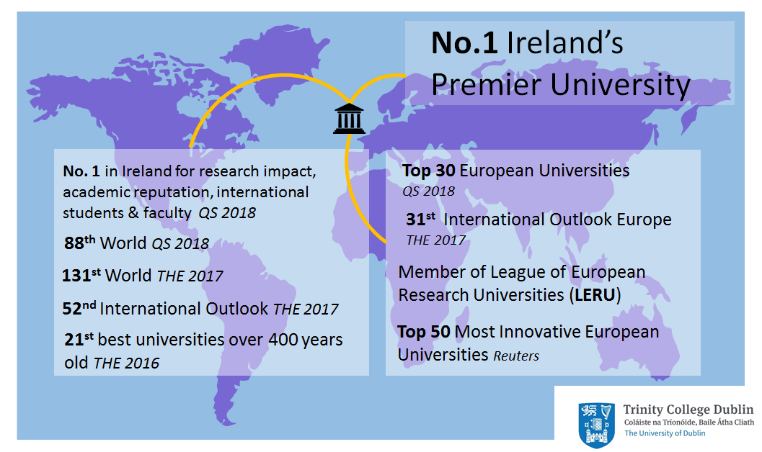
World University Rankings Update (April 2017)
Overall
- Trinity is Ireland’s No.1 University in the QS World University Ranking, THE World University Ranking and the Academic Ranking of World Universities (Shanghai).
- Trinity is ranked 88th in the World, and 29th in Europe, in the 2017/2018 QS World University Ranking.
- Trinity is ranked in the Top 100 for Graduate Employability in the QS 2017 Rankings.
- Trinity is in the Top 50 most innovative universities in Europe according to Reuters.
- Between 2010 and 2015, Trinity was ranked the top university in Europe for entrepreneurship according to Pitchbook’s independent analysis.

Internationalisation

- Trinity is ranked 52nd in the world in the THE World University Ranking for international outlook.

Research Performance

- Of the 981 institutions included in the THE World University Rankings for 2017, Trinity is in the top 15% internationally for research performance.
- Trinity is ranked in the top 15% internationally by QS for citations.

In the QS World University Rankings:

- Trinity featured in the world's elite (Top 200) institutions in 25 of the 28 subjects in which it was evaluated by the QS World University Rankings by Subject in 2015. Of these, Trinity ranked in the top 100 in the world in 14 subjects and in the top 50 in the world in 4 subjects: English Language and Literature; Nursing; Politics and International Studies; History; Biological Sciences; and Modern Languages.
- In three out of the last four years, Trinity has been consistently ranked in the Top 50 worldwide for the following areas: English Language and Literature; Nursing; Modern Languages; and Politics and International Studies.
- In the QS Faculty rankings, Trinity has been consistently ranked in the Top 100 globally for Arts and Humanities over the last four years.

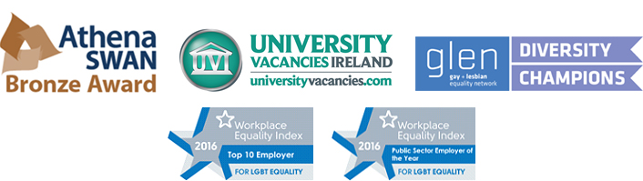

Yunus Emre Institute www.yee.org.tr

Yunus Emre Foundation, a public charity, was founded by law in May 2007 to promote Turkey, Turkish language, its history and culture and art, make such related information and documents available for use in the world, provide services abroad to people who want to have education in the fields of Turkish language, culture and art, to improve the friendship between Turkey and other countries and increase the cultural exchange.
As an institution affiliated to the Foundation, Yunus Emre Institute is carrying out studies for Turkish teaching in the cultural centres established abroad to accomplish the purposes of this law as well as conducting culture and art activities to promote Turkey and giving support to scientific researches.
Starting to operate in 2009, Yunus Emre Insitute has now 54 cultural centres abroad. Apart from the Turkish education given in the cultural centres, Turkology departments and Turkish teaching are supported through cooperation with different educational institutions in different countries. It is one of the biggest in the world with its expansive network of cultural centres in almost 50 countries.
Yunus Emre Institute has the mission to enhance Turkey’s visibility, reliability and reputation in the international arena and thus to contribute to an increase in the number of people all around the world who feel connected to Turkey and consider themselves a friend.
To this end, the Institute focuses its efforts in four fields: teaching Turkish as a foreign language, cultural interaction, scientific interaction, cultural diplomacy and instutitonal development.
Through Turkish courses all over the world, Yunus Emre Institute aims to ensure that people in other countries develop a direct and accurate knowledge of Turkey. The Institute conducts various activities to that end such as Turkish language courses, developing learning materials, teacher training, summer schools, etc.
Through its art and culture activities, Yunus Emre Institute aims to increase the cultural relations between Turkey and other countries with a view to developing a better perception of Turkey and other countries. The main theme of our arts and cultural activies is Turkey’s heritage and production in arts and culture but our institute also includes cultural heritage of other countires in its programme to enable and strengthen cultural interaction and exchange with them through culture. For this purpose YEI organizes hundreds of culture and art events like concerts, conferences, seminars, masterclasses, workshops, film screenings, culinary events etc. throughout the year all over the world.
Yunus Emre Institue aims to introduce Turkey’s scientific and academic knowledge and experience to to the world. As part of our Turkology Project, we support existing Turkology departments, chairs or the courses of universities abroad and encourage the establishment of new ones. As part of TABIP project we aim to strengthen the relations between academic, scientific and technological institutions in Turkey and other countries.
Yunus Emre Institue conducts cultural diplomacy activities to identify new horizons in cultural diplomacy, monitor Turkey’s cultural diplomacy projects and to guide government policies in this field as well as to establish long term relationships with similar instutitutions and projects around the world. For this reason Yunus Emre Institute is a member and the term president of Global Public Diplomacy Network (GPDNET).
Through Yunus Emre Institute Lectureship we aim to help develop and diversify the support for Turkish Studies in the Trinity College and the promotion of Turkish culture in Ireland.
Links to get further information about Yunus Emre Institute
http://www.yee.org.tr/en
https://www.youtube.com/watch?v=4rCRhYx0oec
http://gpdnet.org/user/main/selectMain.do
http://turkceyazokulu.com/en/
https://turkce.yee.org.tr/

http://www.reuters.com/article/us-innovative-stories-europe-idUSKCN0Z00CT
http://pitchbook.com/news/reports/2015-2016-pitchbook-universities-report

